**VISVESVARAYA TECHNOLOGICAL UNIVERSITY**

**“Jnana Sangama”, Belagavi – 590 018**



**A Mini Project Report on**

**“Toll Collecting Booth”**

**Bachelor of Engineering in**

**Computer Science and Engineering**

**Submitted By**

**JOYCE DOLA [2JH20CS027]**

**MD GOUSE M KILLEDAR [2JH20CS042]**

**B PRERNA NAIDU [2JH20CS012]**

**SANJANA ASTOTI [2JH20CS078]**

**Under the Guidance of**

**Prof. Sahana M B**



**Department of Computer Science and Engineering**

**JAIN COLLEGE OF ENGINEERING AND TECHNOLOGY, Hubballi**

**2022 – 2023**

**JAIN COLLEGE OF ENGINEERING AND TECHNOLOGY**

**Department of Computer Science and Engineering**



# CERTIFICATE

Certified that the VI Semester Mini Project in Computer Graphics Laboratory with mini project titled **“Toll Collecting Booth”** carried out by **Ms. Joyce Dola, Mr. Md Gouse M Killedar,**

**Ms. Prerna Naidu, Ms. Sanjana Astoti.** Bearing **USN 2JH20CS027, 2JH20CS042,**

**2JH20CS012, 2JH20CS078 (resp)** a bonafide student of Jain College of Engineering and

Technology, in partial fulfillment for the award of the **BACHELOR OF ENGINEERING** in Computer Science and Engineering from **Visvesvaraya Technological University, Belagavi** during the year 2022-2023. It is certified that all the corrections/suggestions indicated for Internal Assessment have been incorporated in the report submitted in the department library. The Computer Graphics Mini Project report has been approved as it satisfies the academic requirements in respect of the miniproject work prescribed for the said Degree.



Prof.

Sahana M B



Asst

.

Professor



Dept

.

of

CSE



Prof. Maheshkumar Patil



HOD

Dept. of CSE

Name of the Examiners with signature:



## INTRODUCTION

### 1.1 Introduction to Computer Graphics

Computer Graphics is concerned with all aspects of producing pictures or images using a computer. We can create images that are indistinguishable from photographs of real objects. In other terms, Computer Graphics are the graphics created by the computers, and more generally, the representation and manipulation of image data by a computer. The development of computer graphics has been driven both by the needs of the user community and by advances in hardware and software.

Typically, the term Computer Graphics refers to several different things.

* The representation and manipulation of image data by a computer.
* The various technologies used to create and manipulate images.
* The images so produced, and manipulating visual content.

### 1.2 History of Computer Graphics

The phrase Computer Graphics was coined in 1960 by William Fetter, a graphic designer for Boeing. The field of Computer Graphics developed with the emergence of computer graphics hardware. Early projects like the Whirlwind and SAGE projects introduced the CRT as a viable display and interaction interface and introduced the light pen as an input device. Further advances in computing led to greater advancements in interactive computer graphics. In 1959, the TX-2 computer was developed at MIT Lincoln Laboratory. A light pen could be used to draw sketches on the computer using Ivan Sutherlands revolutionary Sketchpad software.

Also, in 1961 another student at MIT, Steve Russell, created the first video game, Space war. E.

E. Zajac, a scientist at Bell Telephone Laboratory (BTL), created a film called “Simulation of a two-giro gravity attitude control system” in 1963. In this computer-generated film, Zajac showed how the attitude of a satellite could be altered as it orbits the Earth. Many of the most important early breakthroughs in computer graphics research occurred at the University of Utah in the 1970s.

The first major advance in 3D computer graphics was created at UU by these early pioneers, the hidden-surface algorithm. In order to draw a representation of a 3D object on the screen, the computer must determine which surfaces are “behind” the object from the viewer’s perspective, and thus should be “hidden” when the computer creates (or renders) the image.

Graphics and application processing were increasingly migrated to the intelligence in the workstation, rather than continuing to rely on central mainframe and mini-computers. 3D graphics became more popular in the 1990s in gaming, multimedia and animation. Computer graphics used in films and video games gradually began to be realistic to the point of entering the uncanny valley. Examples include the later Final Fantasy games and animated films like The Polar Express.

### 1.3 Applications of Computer Graphics

The development of computer graphics has been driven both by the needs of the user community and by advances in hardware and software. The applications of computer graphics are many and varied. We can however divide them into four major areas.

* Display of information: More than 4000 years ago, the Babylonians developed floor plans of buildings on stones. Today, the same type of information is generated by architects using computers. Over the past 150 years, workers in the field of statistics have explored techniques for generating plots. Now, we have computer plotting packages. Supercomputers now allow researchers in many areas to solve previously intractable problems. Thus, Computer Graphics has innumerable applications.
* Design: Professions such as engineering and architecture are concerned with design. Today, the use of interactive graphical tools in CAD, in VLSI circuits, characters for animation have developed in a great way.
* Simulation and animation: One of the most important uses has been in pilots‟ training. Graphical flight simulators have proved to increase safety and reduce expenses.

Simulators can be used for designing robots, plan it’s path, etc. Video games and animated movies can now be made with low expenses.

* User interfaces: Our interaction with computers has become dominated by a visual paradigm. The users‟ access to internet is through graphical network browsers. Thus Computer Graphics plays a major role in all fields.

### 1.4 Introduction to OpenGL

OpenGL is a software interface to graphics hardware. This interface consists of about 150 distinct commands that are used to specify the objects and operations needed to produce interactive three-dimensional applications. OpenGL is designed as a streamlined hardware-independent interface to be implemented on many different hardware platforms.

These are certain characteristics of OpenGL:

* OpenGL is a better documented API.
* OpenGL is much easier to learn and program.
* OpenGL has the best demonstrated 3D performance for any API.

The OpenGL specification describes an abstract API for drawing 2D and 3D graphics. Although it's possible for the API to be implemented entirely in software, it's designed to be implemented mostly or entirely in hardware.

In addition to being language-independent, OpenGL is also platform-independent. The specification says nothing on the subject of obtaining, and managing, an OpenGL context, leaving this as a detail of the underlying windowing system. For the same reason, OpenGL is purely concerned with rendering, providing no APIs related to input, audio, or windowing.

OpenGL is an evolving API. New versions of the OpenGL specification are regularly released by the Khronos Group, each of which extends the API to support various new features. In addition to the features required by the core API, GPU vendors may provide additional functionality in the form of *extensions*. Extensions may introduce new functions and new constants, and may relax or remove restrictions on existing OpenGL functions. Vendors can use extensions to expose custom APIs without needing support from other vendors or the Khronos Group as a whole, which greatly increases the flexibility of OpenGL. All extensions are collected in, and defined by, the OpenGL Registry.

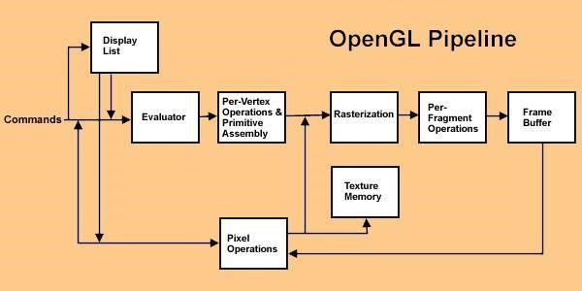

Figure 1.1 OpenGL Pipeline

The OpenGL pipeline consists of several stages or parts that are involved in the rendering process. Here are the main parts of the OpenGL pipeline:

**Application Stage:**

This is the stage where you, as a developer, interact with OpenGL through your application code. You define the geometry, textures, shaders, and other relevant data.

**Vertex Specification Stage:**

In this stage, you define the attributes of your vertices, such as position, color, normal, and texture coordinates. These attributes are organized into vertex buffer objects (VBOs) that hold the vertex data.

**Vertex Shader Stage:**

The vertex shader operates on each vertex of the input geometry. It takes the vertex attributes as inputs and performs transformations on them. It can modify the vertex position, calculate lighting, and apply other operations.

**Tessellation Stages (Optional):**

These stages are optional and are used for more advanced geometry manipulation. They allow for dynamically generating additional vertices and increasing the level of detail in a surface.

**Geometry Shader Stage (Optional):**

The geometry shader takes the output from the vertex shader and can generate additional vertices or primitives. It can create new geometry by emitting points, lines, or triangles, allowing for effects such as particle systems or procedural geometry generation.

**Primitive Assembly Stage:**

This stage assembles the vertices generated by the previous stages into geometric primitives, such as points, lines, or triangles. It also performs optional primitive filtering and clipping.

**Rasterization Stage:**

The rasterization stage converts the geometric primitives into fragments or pixels. It determines which fragments are covered by the primitives and generates a fragment for each covered sample.

**Fragment Shader Stage:**

The fragment shader operates on each fragment generated by the rasterization stage. It calculates the final color and other attributes of each fragment. It can perform per-pixel lighting, texturing, blending, and other operations.

**Per-Sample Operations:**

This stage includes operations like depth testing, stencil testing, alpha blending, and other per-sample operations that determine the final color and visibility of each fragment.

**Framebuffer Operations:**

The final stage involves operations on the framebuffer, such as writing the final color values to the frame buffer and updating the screen.

### 1.5 Introduction to GLUT

GLUT is the OpenGL utility toolkit, a window system independent toolkit for writing OpenGL programs. It implements a simple windowing API for OpenGL. GLUT makes it easier to learn about and explore OpenGL programming. GLUT provides a portable API so you can write a single OpenGL program that works across all PC and workstation OS platforms. GLUT is designed for constructing small to medium sized OpenGL programs.

While GLUT is well-suited to learning OpenGL and developing simple OpenGL applications, GLUT is not a full-featured toolkit so large applications requiringsophisticated user interfaces are better off using native window system toolkits. The GLUT library has both C, C++ (same as C), FORTRAN, and ADA programming bindings. The GLUT source code distribution is portable to nearly all OpenGL implementations and platforms.

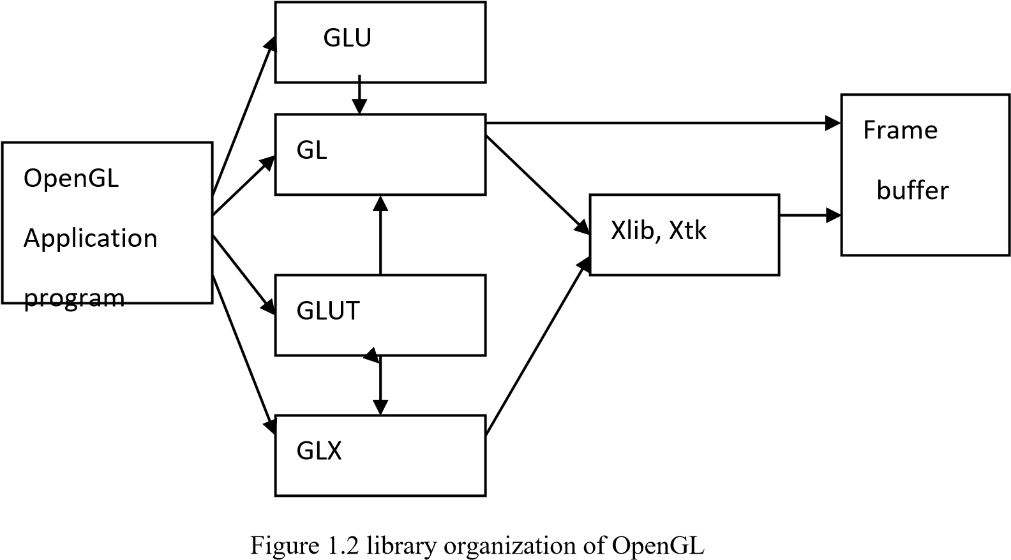

### 1.6 Applications of OpenGL

* **OpenGL** (**Open G**raphics **L**ibrary) is a cross-language, multi-platform API for rendering 2D and 3D computer graphics.
* The API is typically used to interact with a GPU, to achieve hardware accelerated rendering.
* It is widely used in CAD, virtual reality, scientific visualization, information visualization, flight simulation, and video games.

### 1.7 OpenGL primitives

OpenGL supports two classes of primitives:

* Geometric Primitives
* Image (Raster) Primitives

Geometric primitives are specified in the problem domain and include points, line segments, polygons, curves and surfaces. Raster primitives, such as arrays of pixels pass through a separate parallel pipeline on their way to the frame buffer. There are ten basic OpenGL primitives:

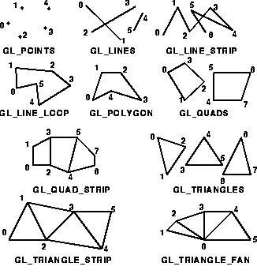

Figure 1.3 OpenGL Primitives

### 2. LITERATURE SURVEY

The basic functions like glColor3f(…); glRotatef(..), glTranslatef(..) etc that are most commonly used in the code are taken from the prescribed VTU Text book “INTERACTIVE COMPUTER GRAPHICS” 5th edition by Edward Angel.[1].

**Physically Based Rendering**:“From Theory to Implementation" by Matt Pharr and Greg Humphreys."Real-Time Rendering" by Tomas Akenine-Möller, Eric Haines, and Naty Hoffman.

"Rendering with Radiance" by Greg Ward.

**3D Modeling and Animation**:"Computer Graphics: Principles and Practice" by James D. Foley, Andries van Dam, Steven K. Feiner, and John F. Hughes.

"Polygon Mesh Processing" by Mario Botsch et al.

"The Animator's Survival Kit" by Richard Williams.

**Virtual Reality (VR) and Augmented Reality (AR):**"Understanding Virtual Reality: Interface, Application, and Design" by William Sherman and Alan Craig.

"Augmented Reality: Principles and Practice" by Dieter Schmalstieg and Tobias Hollerer.

"Virtual Reality: Concepts and Technologies" by Philippe Fuchs.

**Computer Animation:**"Computer Animation: Algorithms and Techniques" by Rick Parent.

"Advanced Animation and Rendering Techniques" edited by Alan Watt and Mark Watt.

"The Illusion of Life: Disney Animation" by Ollie Johnston and Frank Thomas.

**Geometry Processing:**"Discrete Differential Geometry: An Applied Introduction" by Maksim Aizenshtat, Eitan Grinspun, and Mathieu Desbrun.

"Computational Geometry: Algorithms and Applications" by Mark de Berg, Otfried Cheong, Marc van Kreveld, and Mark Overmars.

"Polygon Mesh Processing" by Mario Botsch et al.

The lab programs in the syllabus also serve as a basic template for creating a project. The usage of colors and specifications are taken from the various programs that were taught in the lab.[1]. The VTU prescribed text book serves as a huge database of functions and they are used in the project.

### 3.SYSTEM REQUIREMENTS

The graphics editor has been programmed in C. It makes use of Turbo C Graphics library package for creating the user interface. This is a subroutine library for terminal independent screen painting and input event handling.

**3.1 Hardware Requirements:**

The standard output device is assumed to be a Color Monitor. It is quite essential for any graphics package to have this, as provision of color options to the user is a must. The mouse, the main input device, has to be functional i.e., used to give input in the game. A keyboard is used for controlling and inputting data in the form of characters, numbers i.e., to change the user views. Minimum Requirements expected are cursor movement, creating objects like lines, squares, rectangles, polygons, etc. Transformations on objects/selected area should be possible.

Filling of area with the specified color should be possible.

* Processor: Intel dual core i5.
* RAM: 1GB RAM or above.
* Input devices: Keyboard.
* Output devices: Monitor.

**3.2Software Requirements:**

The editor has been implemented on the OpenGL platform and mainly requires the appropriate version of Microsoft Visual Studio.

* Operating System: Microsoft Windows 10.
* Microsoft Visual Studio 2010
* glut.h header file
* glut.dll library file

### 4.ABOUT THE PROJECT

**4.1 PROPOSED SYSTEM:**

To achieve three dimensional effects, OpenGL software is proposed. It is software which provides a graphical interface. It is a interface between application program and graphics hardware. The advantages are:

1. OpenGL is designed as a streamlined.
2. It is a hardware independent interface i.e., it can be implemented on many different hardware platforms.
3. With OpenGL, we can draw a small set of geometric primitives such as points, lines and polygons etc.
4. It provides double buffering which is vital in providing transformations.
5. It is event driven software.
6. It provides call back function.

**Main theme of the project is:**

The main idea behind this project is to display the concept of toll collecting booth with computer graphics. This graphics package is based on the OpenGL library functions. The programming language used here is C using OpenGL libraries. The idea behind this project is to display the concept of toll collection booths through computer graphics. This project will include a toll collecting booth where as soon as the car comes the barrier is imposed. This barrier will then be lifted by the user. There will be two way path in at both way we have at toll collecting booth for both direction. To open the left side barrier we use to press “L|l” key, as soon as the key is pressed the left side car will move. And in the same way, we have “R|r” key to open the barrier and allow the car to move further. Here we also we can increase or decrease the speed of the cars by using proper keys.

It aims to create a realistic 3D representation of a toll booth environment using the OpenGL graphics API. The project focuses on modeling, texturing, lighting, and interactivity to provide an immersive toll booth experience.

**Goals of the project:**

1. Create a visually realistic toll booth environment using OpenGL.
2. Simulate the toll collection process and provide user interaction.
3. Emphasize attention to detail and focus on achieving a high level of realism.
4. Explore and implement various OpenGL techniques and concepts, including modeling, texturing, lighting, and shading.
5. Optimize the rendering process for smooth performance.

**4.3 DATA FLOW MODEL OF THE PROJECT:**

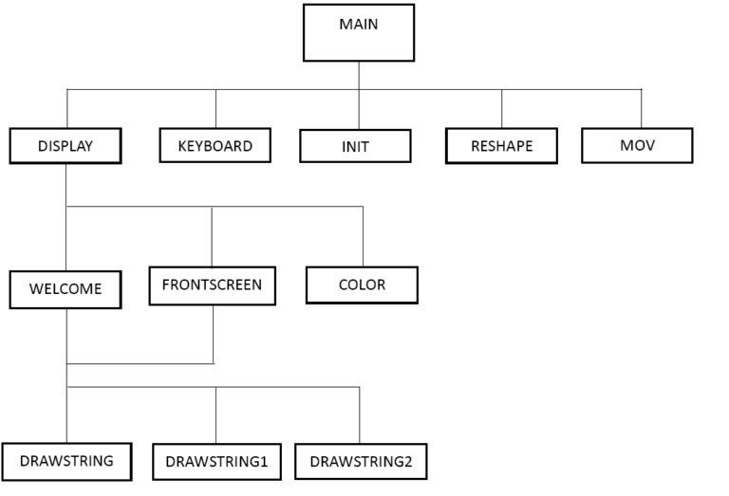

**4.4 ALGORITHM:**

1. Initialize OpenGL environment.

2. Set up window and viewport settings.

3. Define toll booth variables:

- Booth position (x, y)

- Barrier position (x, y)

- Vehicle position (x, y)

- Toll amount

- Vehicle speed

- Vehicle direction (left or right)

- Barrier state (up or down)

4. Implement rendering functions:

- Render booth

- Render barriers

- Render vehicles

5. While simulation is active:

- Handle user input (e.g., key presses)

- Update vehicle position based on speed and direction

- Check for collision between vehicle and barrier

- If collision occurs:

- If barrier is down:

- Collect toll from vehicle

- Open barrier

- If barrier is up:

- Vehicle crashes or stops (handle as desired)

6. Render toll booth, barriers, and vehicles.

7. Cleanup and release resources.

8. Exit program.

#### Module Description:

**MAIN FUNCTION:** Main is a function from which execution of the program ill start. It initializes the window of size 1000*1000 pixels. And also call various functions defined in the program, also includes a menu which intern calls the related functions (such as my menu, submenu, etc…).

**MYINIT FUNCTION:** This function is used to convert one coordinate system to another coordinate system. We used the GL_MatrixMode(GL_PROJECTION) and glLoadIdentity() in this function.

**MENU FUNCTION:** It creates the main and the sub-menus, whereas the main menu is to “Quit, increase the size and decrease size” of the objects. And sub-menus are used for color. The menu is assigned to mouse click when the mouse (LEFT or RIGHT) button is pressed the menu will appear and action is performed.

**MOUSE FUNCTION:** This is an event-driven function which is used to select the objects. Here in this project, we have used this mouse function to select the paint objects, specified in a specific region.

#### GLSL Built-in Variables

There are two very important built-in variables in GLSL. Without their use in shaders, no rendering will occur. They are:

* gl_Position;
* gl_FragColor; **gl_Position**

The gl_Position is used by the vertex shader to hand over the **transformed** vertex position to the OpenGL pipeline.

#### gl_FragColor

The gl_FragColor is used by the fragment shader to hand over the color of the fragment to the OpenGL pipeline.

The gl_Position and gl_FragColor variables are mandatory in the vertex and fragment shaders, respectively.

### 5.IMPLEMENTATION

**5.1 FUNCTIONS USED**

**Void glColor3f(float red, float green, float blue):**

This function is used to mention the color in which the pixel should appear. The number 3 specifies the number of arguments that the function would take. “f “ gives the type that is float. The arguments are in the order RGB (Red, Green, Blue). The color of the pixel can be specified as the combination of these 3 primary colors.

**Void glClearColor(int red, int green, int blue, int alpha):**

This function is used to clear the color of the screen. The 4 values that are passed as arguments for this function are (RED, GREEN, BLUE, ALPHA) where the red green and blue components are taken to set the background color and alpha is a value that specifies depth of the window. It is used for 3D images.

**Void glutKeyboardFunc():**

**void glutKeyboardFunc(void (*func)(unsigned char key, int x, int y));** where func is the

new keyboard callback function. glutKeyboardFunc sets the keyboard callback for the current window. When a user types into the window, each key press generating an ASCII character will generate a keyboard callback. The key callback parameter is the generated ASCII character. The x and y callback parameters indicate the mouse location in window relative coordinates when the key was pressed. When a new window is created, no keyboard callback is initially registered, and ASCII key strokes in the window are ignored. Passing NULL to glutKeyboardFunc disables the generation of keyboard callbacks.

**Void glFlush():**

Different GL implementations buffer commands in several different locations, including network buffers and the graphics accelerator itself. glFlush empties all of these buffers, causing all issued commands to be executed as quickly as they are accepted by the actual rendering engine.

**Void glMatrixMode(GLenum mode):**

where mode Specifies which matrix stack is the target for subsequent matrix operations. Three values are accepted: **GL_MODELVIEW, GL_PROJECTION, and GL_TEXTURE.** The initial value is **GL_MODELVIEW**. **glMatrixMode** sets the current matrix mode. Mode can assume one of three values:

**GL_MODELVIEW:** Applies subsequent matrix operations to the model view matrix stack.

**GL_PROJECTION:** Applies subsequent matrix operations to the projection matrix stack.

**void glutInit(int *argc, char **argv):**

glutInit will initialize the GLUT library and negotiate a session with the window system. During this process, glutInit may cause the termination of the GLUT program with an error message to the user if GLUT cannot be properly initialized. Examples of this situation include the failure to connect to the window system, the lack of window system support for OpenGL, and invalid command line options. glutInit also processes command line options, but the specific options parse are window system dependent. **void glutReshapeFunc(void (*func)(int width, int height)):**

glutReshapeFunc sets the reshape callback for the current window. The reshape callback is

triggered when a window is reshaped. A reshape callback is also triggered immediately before a window's first display callback after a window is created or whenever an overlay for the window is established. The width and height parameters of the callback specify the new window size in pixels. Before the callback, the current window is set to the window that has been reshaped. **void glutMainLoop(void):**

glutMainLoop enters the GLUT event processing loop. This routine should be called at most once in a GLUT program. Once called, this routine will never **glutPostRedisplay():**

glutPostRedisplay, glutPostWindowRedisplay — marks the current or specified window as needing to be redisplayed.

### 6.SNAP SHOTS

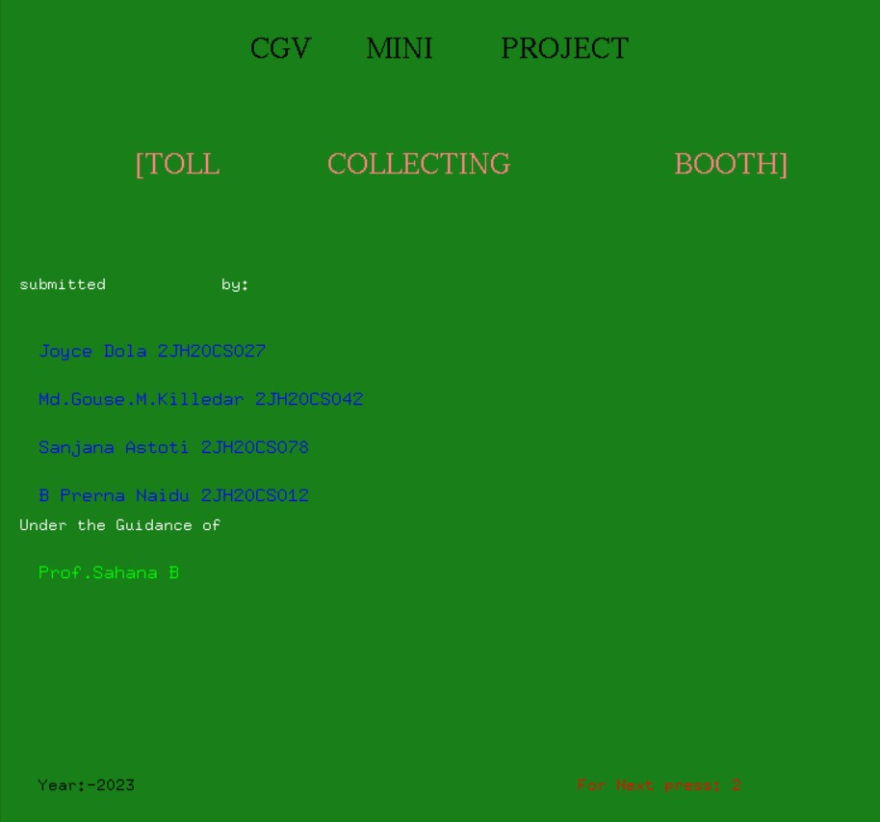

Introduction page of the project.

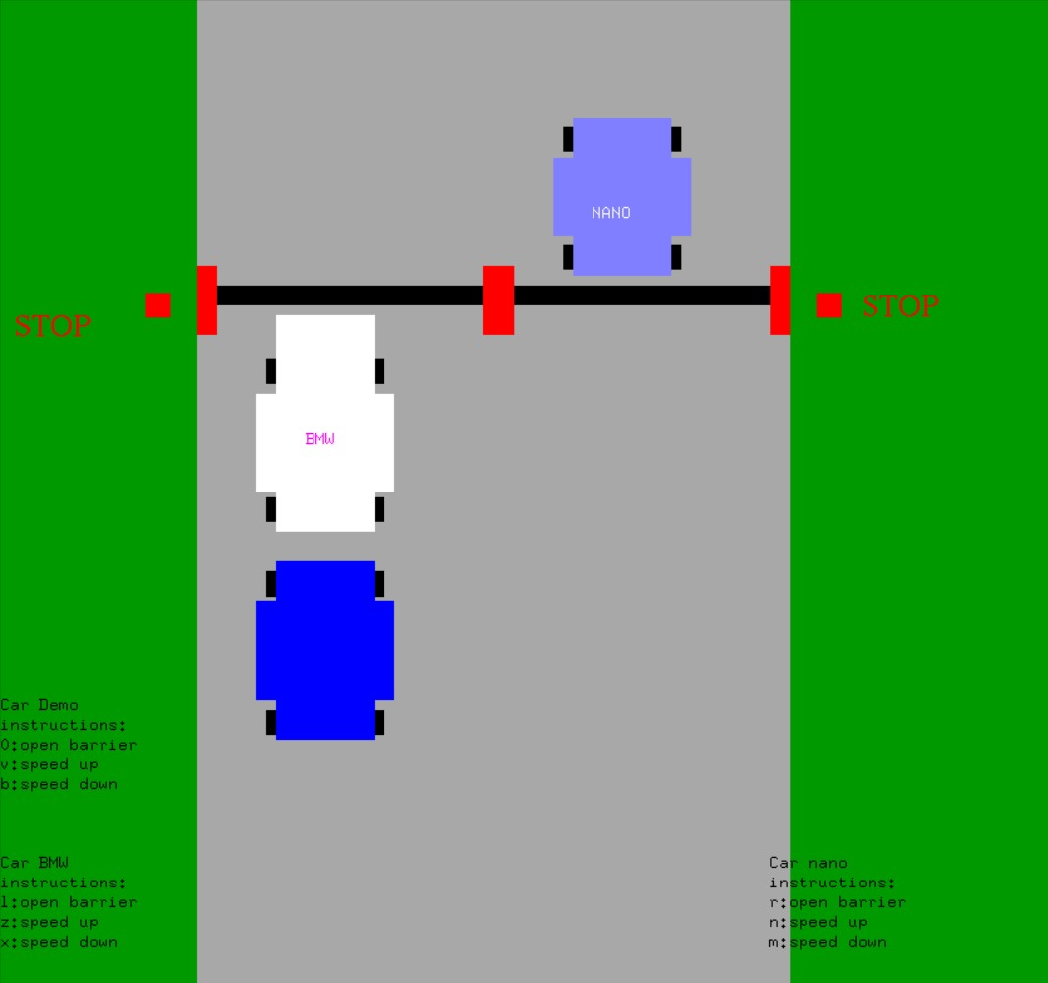

BMW car and Nano car are paying toll.

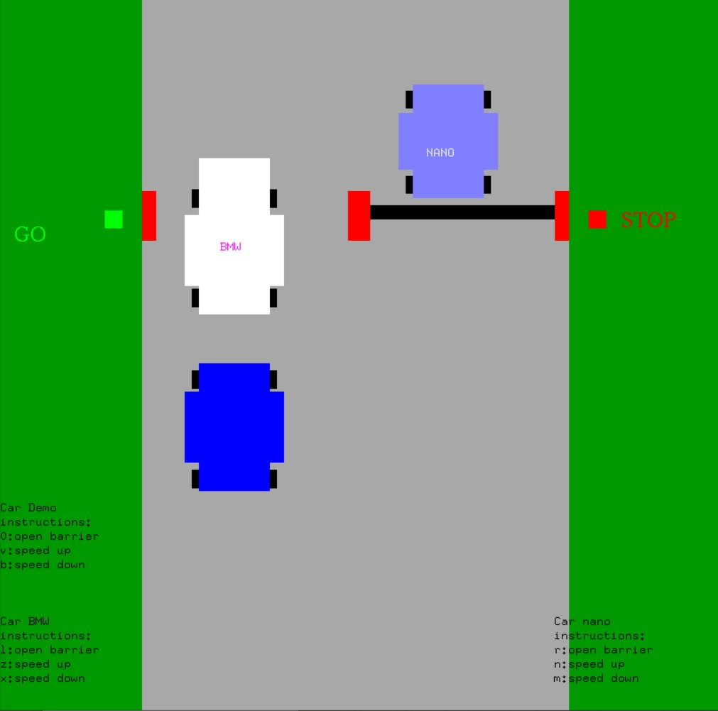

After paying toll car BMW went and the next car is waiting to pay the toll

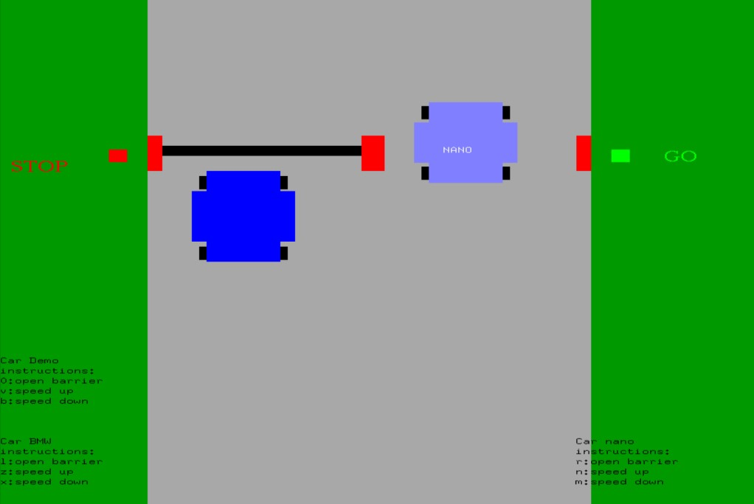

As soon as we pay the toll the barriers will open and car will move, from both sides.

**7.CONCLUSION AND FUTURE SCOPE**

Electronic toll collection system allows the vehicle drives to pass the toll tax booths without stopping at the toll booth. The toll amount is deduced from the RFID card. This RFID cards is rechargeable and account is stopped on the records. Automatic Toll Tax systems have really helped a lot in reducing the heavy congestion caused in the metropolitan cities of today. It is one of the easiest methods used to organize the heavy flow of traffic. When the car moves through the toll gate on any road, it is indicated on the RFID reader that it has crossed the clearing. The need for manual toll-based systems is completely reduced in this methods and the tolling system works through RFID. The system thus installed is quite expedient reducing the time and cost of travellers since the tag can be deciphered from a distance. As we all know that transportation is the backbone of any country’s economy. Improvement in transportation systems result into the good lifestyle in which we achieve extraordinary freedom for movement, immense trade in manufactured goods and services, as well as higher rate of employment levels and social ability. In fact, the economic condition of a nation has been closely related to efficient ways of transportation. Increasing number of vehicles on the road, result into number of problems such as congestion, accident rate, air pollution and many others One of the important aspects of modern electronic technology is embedded systems based on micro controllers. The main aim of science has always been to make our lives easier. In this project, we discuss an innovative concept of tool booth. Some of the issues faced by customer are: Wastage of valuable time, Traffic jam and money loss, fuel loss. The necessity for vehicles to stop or slow down for toll fee payment results in traffic congestion and reduces fuel efficiency. Hence, a system that enables road users to pay the toll fees without stopping or slowing down was proposed and developed. Hardware and software designs were carried out to develop a RFID based highway toll collection system. This system has developed using a microcontroller. Different modules such as GSM module, Liquid Crystal Display (LCD) module.

### 8.FUTURE ENHANCEMENTS

This project has been designed such that it works on the windows platform. The project can be designed using different languages and better graphical interfaces. The following features can be incorporated. This project aims to improve the visual quality, interactivity, realism, and functionality of the toll collecting booth project using OpenGL.

**9.Pseudo Code**

Initialize graphics engine and resources

Create toll booth scene

Load 3D models for toll booth, vehicles, and environment

Set up camera and lighting

Create vehicle object

Set initial position, orientation, and velocity

Load vehicle model and textures

Initialize toll collection variables:

totalCollected = 0 // Total amount collected

vehicleCount = 0 // Total number of vehicles passed through

Create toll collection loop

while booth is active do

Render toll booth scene

Handle user input (e.g., keyboard or mouse)

Update vehicle state

Apply physics simulation (e.g., forces, velocity, position)

Perform collision detection with toll booth or other objects

Render vehicle and environment

Check for collision with toll booth

if collision occurs then

Display instructions and prompt for toll payment

Read toll payment input from user

if payment is valid and sufficient then

Increment totalCollected by payment amount

Increment vehicleCount by 1

Display receipt and thank you message

else

Display error message and ask for correct payment

end if

end if

end toll collection loop

Display summary information:

Display total amount collected

Display total number of vehicles passed through

Calculate and display average toll per vehicle

Clean up resources and exit

### 10.BIBLOGRAPHY

1. F.S. Hill Jr: “COMPUTER GRAPHICS USING OPENGL, 2nd
2. EDITION”.
3. James D. Foley, John.F. Hughes: “COMPUTER GRAPHICS ,1997.”
4. Donald Hearn and Pauline baker: “COMPUTER GRAPHICS” C-Version,2nd edition, Pearson Education, 2003.
5. Internet source: www.angelfire.com Wikipedia.org.

Google.

Opengl.org.